
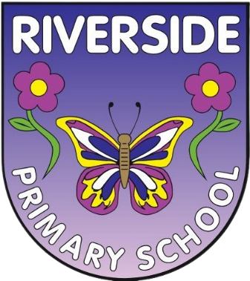

Our Safeguarding
Policy
Child-friendly version

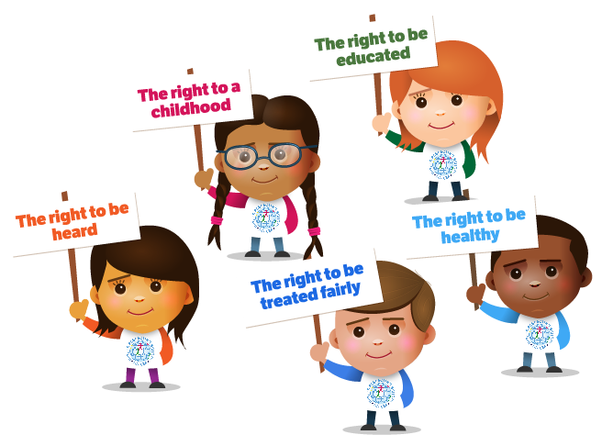

All children and young people have the right to feel safe.

When we feel safe we usually feel good about ourselves.
We can relax and enjoy life.

Children’s rights in England – rights4children

What is this?
Your school has a safeguarding policy for staff, families and governors. This child friendly policy is designed for children within primary school.

What is it for?
To help you decide what could be a problem and where to go to get help and support.
Riverside Primary is our school and we want it to be a safe place. The adults in Riverside Primary will do everything they can to make sure you are protected and happy. To help them do this they have lots of rules to follow. This policy is to help you understand what safeguarding means and to help you decide what could be a “problem” and who you should talk to.
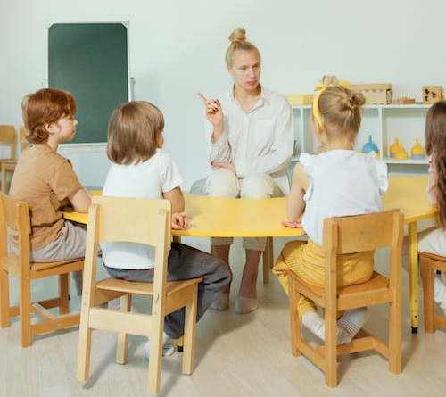
The adults in school think that safeguarding means that they should:
• Protect you from harm;
• Make sure nothing stops you being healthy or developing properly;
• Make sure you are safely looked after;
• Make sure you have the best life chances and can grow up happy and successful


They agree that to make sure they look after you they will:
• Make the school a friendly, welcoming and supportive place to spend time in – somewhere you want to be
• Be there for you to talk to if you need to and know who to ask for help
• Give you safe messages in your lessons to help you learn how to look after yourself both online and in the real world
• Have all the right rules in place to help look after you.

They will follow these rules all of the time (these rules are sometimes called policies)

Abuse
When someone hurts you it can be called abuse. This is when someone does something to you that is harmful, unpleasant or painful like:
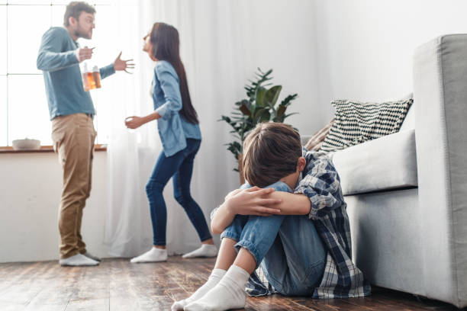
• If someone deliberately hits you, hurts you, injures you or humiliates you in different ways.
• If someone says or does something that makes you feel bad about yourself or hurts your feelings, which makes you feel scared, sad, upset or frightened.
• If someone shouts, threatens, hits or hurts someone you love whilst you are around which makes you scared, unhappy or worried
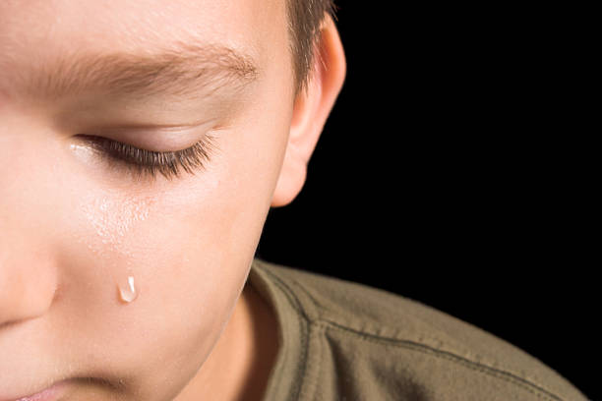
• If someone doesn’t take proper care of you so you feel abandoned, lonely or neglected. You might not be able to eat or wash regularly, or you might not be able to come to school every day or on time.
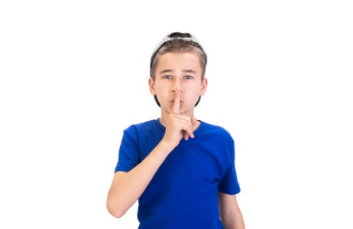
• If someone touches you in a way that you don’t like (like touching your private parts) or makes you look at things which make you feel ashamed, embarrassed, uncomfortable or guilty.
They may ask you to keep it a secret or give you presents. Abuse is never ok and if you are being or have been abused you must remember – it is not your fault. You must always tell someone and they will help it to stop.

In and Out of School
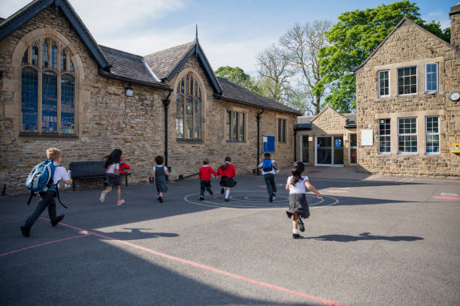
All of the staff at Riverside Primary will do their best to make sure the building is safe for you to learn in and spend time in. We will make sure that we know who everyone is in the school by asking visitors to sign in at reception. You will always know who a visitor to the school is because they will have signed in at reception and will be wearing a visitor badge. People that we do not know will never be allowed to spend time with you on your own and will not be allowed to walk around the school without a member of staff. The building, outside areas and fields will be as safe as they can be for you so that you don’t hurt yourself, although accidents can happen if you are not careful! Staff will look after you if the fire alarm goes off and you should know what to do and where to go. When you leave school to go on a trip somewhere, the staff will make sure they can keep you safe wherever you are going.

What we will do
At Riverside Primary we will help you in the following ways:

• We will do our best to spot if there is a problem. All of the adults in school have had lessons in this
• We will work with other people (including the people at home and people who work in other places) to help protect you and solve any problems you may have
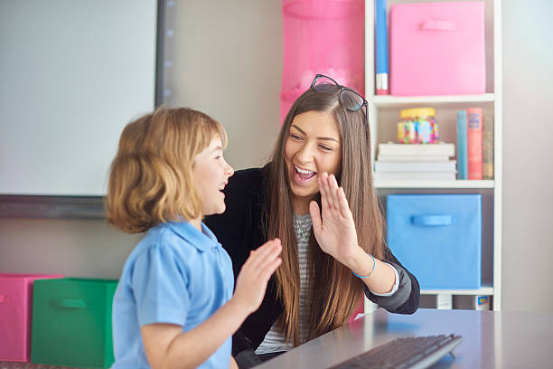
• We will listen to you if you want to talk to us and need our help. We will always take you seriously
• We will support and encourage you and will respect your wishes and views
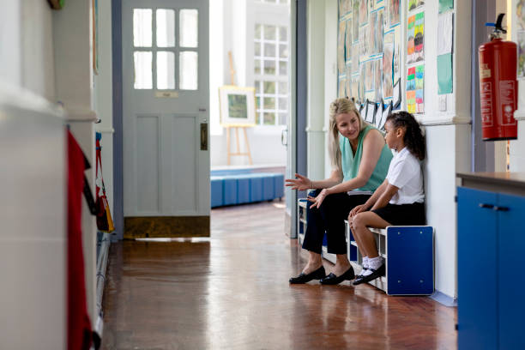
In Riverside Primary you can talk to any member of staff, but you should know that there are a number of staff who are responsible for making sure you are safe and well cared for, and they are listed below. It is important that you know….
• It is never your fault if someone is hurting or abusing you
• There is always someone who can help you
• If someone is hurting you, they might also be hurting someone else so it is important that you tell someone to make it stop
• Every child should enjoy their right to a happy and safe childhood DO NOT BE SCARED TO TELL SOMEONE STRAIGHT AWAY – WE WILL ALWAYS LISTEN
- If you feel an adult has not listened, share this with them if you can. If not there are safeguarding leads in our school who you can share that you did not feel listened to
Tips for keeping yourself safe
Bullying
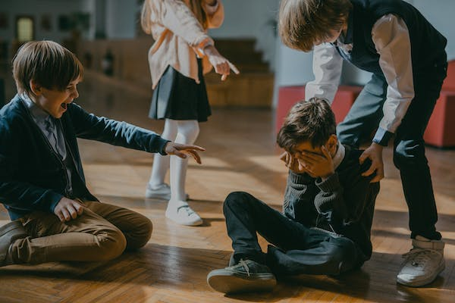
If you think a pupil or a grown up is bullying you or someone you know, you must tell your mum or dad, a teacher or someone you can trust as soon as you can.
Saying funny things to you
If a pupil or a grown up says something to you, or you hear something that you do not like or that upsets you, you must tell your mum or dad, a teacher or someone you can trust.
Touching you
Your body belongs to you and not to anyone else. This means all of your body. If someone touches you on a part of your body like your bottom, chest or anywhere else you do not like, it is not ok. You must tell your mum or dad, a teacher or someone you can trust as soon as you can.
Hitting, punching or smacking you
If a pupil or a grown up hits, punches or smacks you or hurts you in any way, you must tell your mum or dad, a teacher or someone you can trust as soon as you can.
Secrets
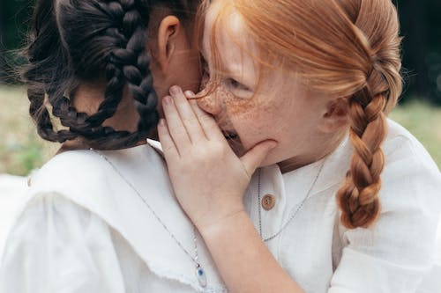
Secrets such as surprise parties are fun, but some secrets are not good and should never be kept. Bullying should not be kept a secret and no-one should ask you to keep a kiss, hug or touch a secret. You must tell your mum or dad, a teacher or someone you can trust as soon as you can. Do not keep a secret.
Presents

Presents are a good thing to get, but you should not take a present from anyone without checking with your parents first. Most of the time it will be ok, but sometimes people try and trick children into doing something by giving them presents (like sweets, money or phones) This is sometimes called a bribe. If it does not seem right, tell someone as soon as you can.

On the computer or your phone


Computers and mobile phones help us all to share things and talk to our friends or family, but they can also make it easier for bullies and other people that want to hurt you to get close to you. It is important to know how to keep yourself safe on your computer, your phone and on websites. Riverside Primary has an e-safety policy which is there to protect you. If you are unhappy with any comments or photographs you’ve seen on your computer or mobile then you can also contact https://www.ceop.police.uk/Safety-Centre/How-can-CEOP-help-me-YP/
as well as adults in school.
People in school who can help you:
• Class Teacher
• Teaching Assistants
• Mrs Yilmaz
• Mrs Ready
• Miss Cameron
• Any other adult in school

Useful Numbers and Websites
Childline 0800 11 11
https://www.nspcc.org.uk/keeping-children-safe/our-services/childline
NSPCC – 0808 800 5000

If you don’t feel you can speak to someone you can complete a form and place it in the ‘Let’s talk’ box, in The Hut.

Name:
I would like to talk to ……………………………………………………………………………………………………………………
about ………………………………………………………………………………………………………………………………………………..
……………………………………………………………………………………………………………………….......................................
………………………………………………………………………………………………………………………………………………………………
……………………………………………………………………………………………………………………………………………………………..
……………………………………………………………………………………………………………………………………………………………...

Please put your form in the ‘let’s talk’ box, in The Hut.

